1. Click on the user from the top right corner and go to my account

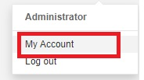

1. Go to security and provide a meaningful name of the token and click on generate button.

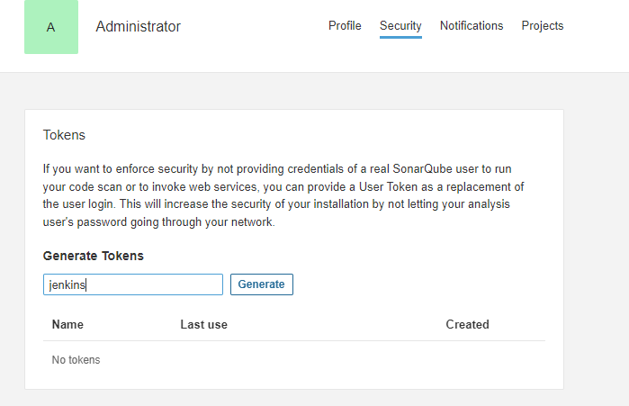

1. Copy the token to create a new secret in Jenkins.